One a day 2020

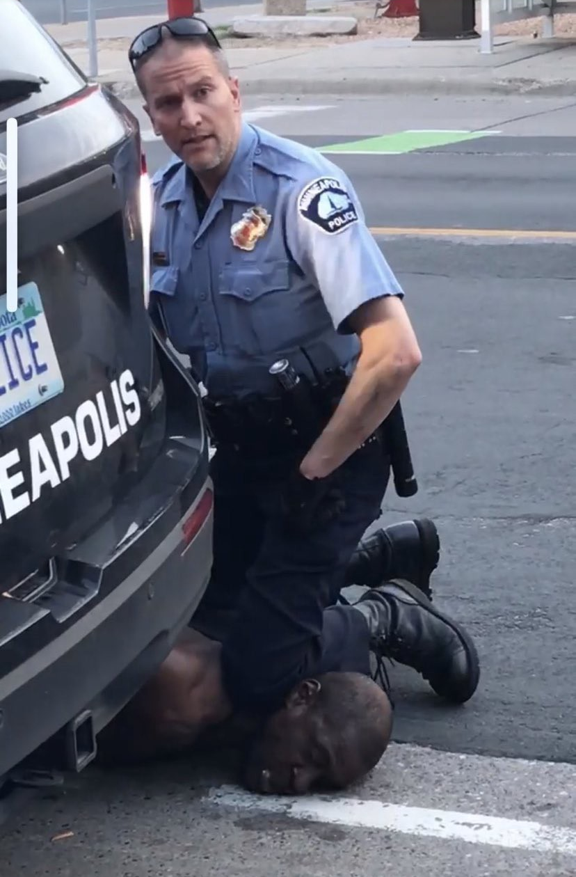
One a day
Eric Garner
Sandra Bland
Akai Gurley
Nicolas Heyward
Yvette Smith
Elijah McClain
Like multi-vitamins
Or stranger fruit
No longer hanging like trophies
At the neighborhood picnic
Where you simply picked a nigger

One a day
And I guess any nigger will still do
So it goes…
All the way back Till
Emmett and Medgar Evers
Amadou Diallo
Rumain Brisbon
Cameron Tillman
Jordan Edwards
Bernard Bailey
There must be Grand Dragons
On the Grand Juries
‘Cause we can’t get you to indict
On back seat suicides,
Accidentally on purpose homicides
Or incontrovertible illegal strangleholds

One a day
Trayvon Martin
Tamir Rice
Ezell Ford
Kiwane Carrington
Aiyana Jones
Shereese Francis
DeAunta Farrow
Tanisha Anderson
From Oaktown to Chi-town
From the Big Easy to the Big Apple
From Pasadena to LA, San Diego to the Bay
Not a one had a Mack to put down
Not even Michael Brown

One a day
Eleanor Bumpurs
Dante Parker
Victor White III
Sgt. Manuel Loggins
Reynaldo Cuevas
Reika Boyd
Botham Jean
Atatiana Jefferson
Raheim Brown
Ousmane Zongo
Ain’t here no more
Cain’t hear no more
But they’d ask you to put your ear to the floor
Ask you from the nether side of the door
Can you hear the jackboots coming?
Can you hear the jackboots coming?
Eyes right as they pass the grandstand
Left right left right, grand gesture
Sieg Heil! Left right, left right
Marginalized, ostracized, victimized and criminalized
Now they’re working on the next step of the final solution
Make that quantum leap from back seat suicide
To all out genocide

One a day
Maybe a double tap on Sunday
John Crawford
Oscar Grant
Miriam Carey
Betty Jones
Natasha McKenna
Pamela Turner
Kimani Gray
We die living out 12-year-old dreams of GTA
Being in the wrong hallway
Standing in our own doorways
Trying to take the safe way
Getting on the subway

One a day
Tyree Woodson
Might not have been a good son
Ramarley Graham
Might have been dealing weed
But, Kenneth Chamberlain
Got two in the chest ‘cause
His medic alert heart monitor
Brought the police to his door
Wendell Allen
Barefoot and wearing only jeans
Came out his bedroom door
To see who was busting down the front door
Wound up bleeding out on his momma’s floor
And not a single one
Had
A
Gun
In his hand

One a day
Freddie Gray
Philando Castile
Javier Ambler
Breonna Taylor
Ahmaud Arbery
George Floyd
Antonio Valenzuela
Manuel Ellis
Beyond the menace and the malice
We let them walk away from murder most foul
And all we’re left with is technicolor video evidence
Mute testament to our collective impotence
Hashtags and Memorials
Raised fists and not so peaceful protests
To lives squandered
In a world where the blackest crime
Is simply blackness

One a day
McKenzie Cochran
Andy Lopez
Dieon Fludd
Tony McDade
Johnnie Kamahi Warren
Nehemiah Dillard
Alonzo Ashley
Steven E. Washington
Tarika Wilson
Walking dead
Now Talking heads
And blow hard coke heads
Want to Factor in race, and criminality
Forget their shared humanity
Forget that they were loved by somebody
Forget the two seconds it took to kill a twelve-year-old
Forget the grenade they dropped in house with a sleeping seven-year-old
Forget the autistic and the schizophrenic falling to a hail of lead
Convince yourselves that they’re all better off dead
Better yet, let them buy your silence
With grim rationalizations
After all, it’s only
One a day

©H²14/20

